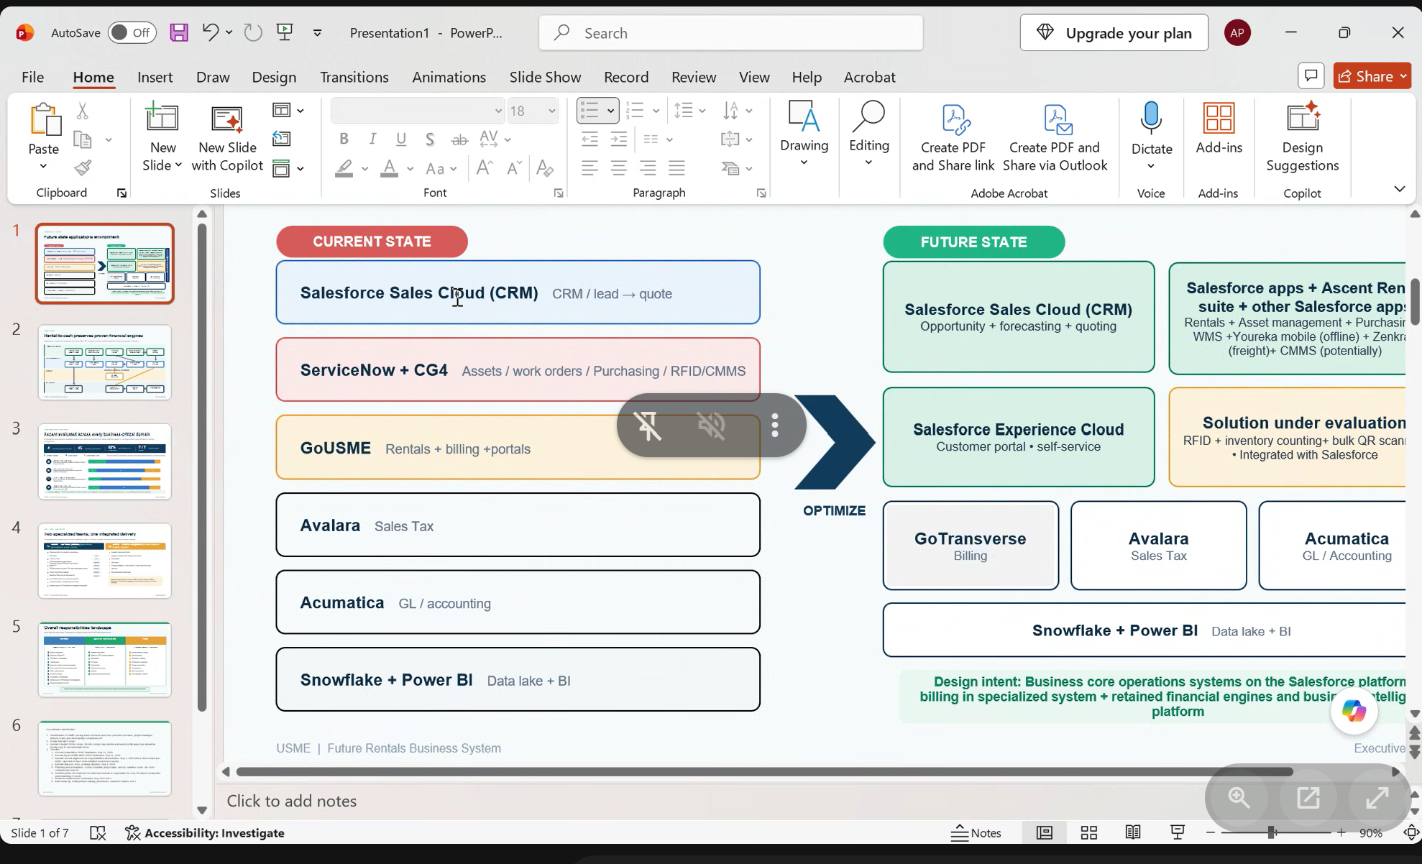

2 mobile apps
Gousme
Assessment -> Hosptials -> Med equipment, invientory, prenventive cleaning maintannce – Asset managed services.
USME stationed at hospitals
RFID -> Scan and then CG4 application takes the reading and this med equip is located and
And sends the info to service now for inventory count and movement, inspection.
It’s a offline app which will scan if no internet and works with service now
CMMS - > Preventive Maintenance, Pressure Readings, maintance for equipments. Hospital owned eqipments
And manged in service now.

